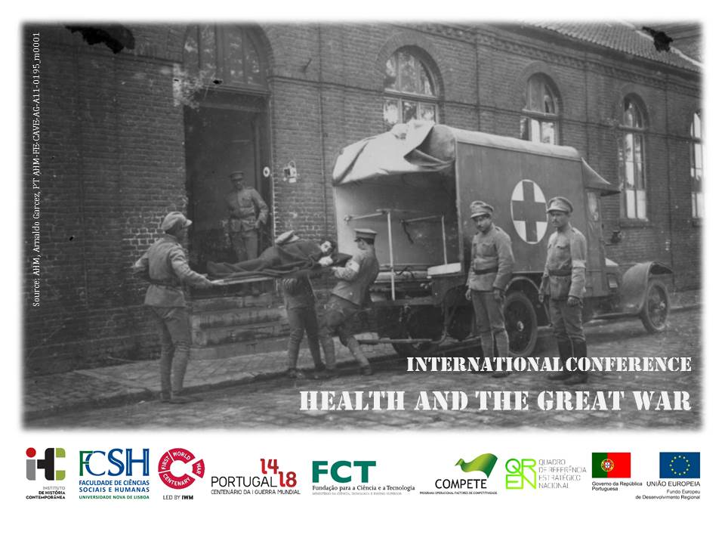
Venue: Lisbon, FCSH/NOVA
Date: 16th December 2015

>> Deadline for proposal submission: until 15th September 2015

A large number of men got ill or were wounded during the Great War. The use of advanced weaponry caused massive injuries and an outstanding number of casualties, leaving soldiers physically and psychological shocked, sick or mutilated. Furthermore, the lack of hygienic conditions, from troops’ transportation to the daily life in trenches, led to the outbreak of epidemic diseases, such as tuberculosis, typhus, smallpox and influenza, culminating in the 1918 Influenza Pandemic, killing over 50 million worldwide. In the African theatre of operations other health issues were raised with the lack of water and endemic diseases, such as malaria, that strongly affected the troops.
Trying to fight this reality, different health services were created to treat and care for this war-wounded. The violence of the conflict required a set of scientific and technological developments, present during and after the war. Doctors and different health professionals worked hand in hand to improve soldiers’ well-being.
We welcome proposals for papers on health and the Great War in all fronts, suggesting the following points:
- Great War and health conditions
- Hygiene during soldiers’ transportation and deportation
- Military health services and war theatres
- Campaign hospitals and health care providers
- Surgery, treatments and war-wounded recovery
- War, scientific and technological development and research
- Medical diplomacy and cooperation
- International and transnational health organizations

Submissions:
Please submit your proposal to healthgreatwar@gmail.com. Proposals should include title, abstract (up to 500 words), keywords (up to 5), institutional affiliation, contact details and a brief CV or bio.
We accept papers in English, French, Portuguese or Spanish; there will be no simultaneous translation.

Fee:
5,00 € – students
10,00 € – other researchers

Organisation:
Ana Carina Azevedo (IHC-FCSH/NOVA), Ângela Salgueiro (IHC-FCSH/NOVA), Helena da Silva (IHC-FCSH/NOVA and GRIC-Université du Havre), Margarida Portela (IHC-FCSH/NOVA), Ricardo Castro (IHC-FCSH/NOVA)

Scientific Committee:
Ana Paula Pires (IHC-FCSH/NOVA), Cláudia Pinto Ribeiro (Faculdade de Letras da Universidade do Porto/CITCEM), Maria de Fátima Nunes (UE, IHC-CEHFCI/UE, FCSH), Maria Fernanda Rollo (IHC-FCSH/NOVA), Helena da Silva (IHC-FCSH/NOVA et GRIC-Université du Havre), José Pedro Sousa Dias (UL-MUHNAC, IHC-CEHFCI/UE, FCSH), LCL Rémy Porte (Officier référent ‘Histoire’ pour l’armée de Terre, Etat-major de l’armée de Terre), Ricardo Castro (IHC-FCSH/NOVA)
Web: https://healthandgreatwar.wordpress.com/

